Project Manager: < Name >

Change Control

|  |  |  |  |
| --- | --- | --- | --- |
| Revision | Date | Author | Details of Change |
| 1 | 22nd July 2015 | AK | Initial document |
|  |  |  |  |

Estimated Development Days: <Number>

If the customer identifies new requirements beyond the scope of this document a new revision will be prepared incorporating those requirements. This may result in changes to the Estimated Development.

This document is strictly confidential and all reasonable steps must be taken to protect such confidentiality. In particular, no other software or IT supplier may be given access to this document or any information contained herein without the written permission of Modular4.

Contents

1.0 Introduction 3

1.1 Customer business requirement 3

1.2 Proposed solution 3

1.3 Assumption and exclusion 3

2.0 Database Changes 4

2.1 New Tables 4

2.1.1 MT_Brokerdetails 4

3.0 New Form MT101 – Broker details 5

3.1 Form specification 5

3.2 Field validations 6

# 1.0 Introduction

## 1.1 Customer business requirement

When the margin trading account creation have to maintain related account broker detail. Broker is responsible to handle margin account on behalf of the customer. Company has to deal with the broker regarding the margin account transaction. Company has to maintain broker balance separately. Margin trading account related payment & receipts should maintain under broker account. Company has to give information to the broker as well as company received information from broker related margin trading account.

## 1.2 Proposed solution

New screen that will be used to record broker details .System has to maintain unique code for broker. Broker details has to maintain under this code like name, address, contact details, etc. for the payment and receipting purposes we have to link with the main system customer database. In the broker detail system has to maintain original client code.

## 1.3 Assumption and exclusion

Before the broker details creation user has to create as client code for this broker in the main system.

# 2.0 Database Changes

## 2.1 New Tables

### 2.1.1 MT_Brokerdetails

|  |  |  |  |
| --- | --- | --- | --- |
| Column | Description | Type | Mandatory |
| Broker_code | Unique code for broker identification | VARCHAR(4) | Y |
| Broker_name | Broker company name | VARCHAR(60) | Y |
| AddressLine1 | Address line 1 | VARCHAR(30) | Y |
| AddressLine2 | Address line 2 | VARCHAR(30) | N |
| AddressLine3 | Address line 3 | VARCHAR(30) | N |
| AddressLine4 | Address line 4 | VARCHAR(30) | Y |
| Telephone | Telephone Number | VARCHAR(30) | Y |
| FaxNumber | Fax Number | VARCHAR(30) | Y |
| Emailid | Email ID | VARCHAR(30) | Y |
| Map_client | Main system client code for broker | VARCHAR(10) | Y |
| Contact_person | Contact person name | VARCHAR(50) | N |
| Broker_status | Broker status (active , inactive) | VARCHAR(1) | Y |

# 3.0 New Form MT101 – Broker details

This new form well be added to the under reference data.

## 3.1 Form specification

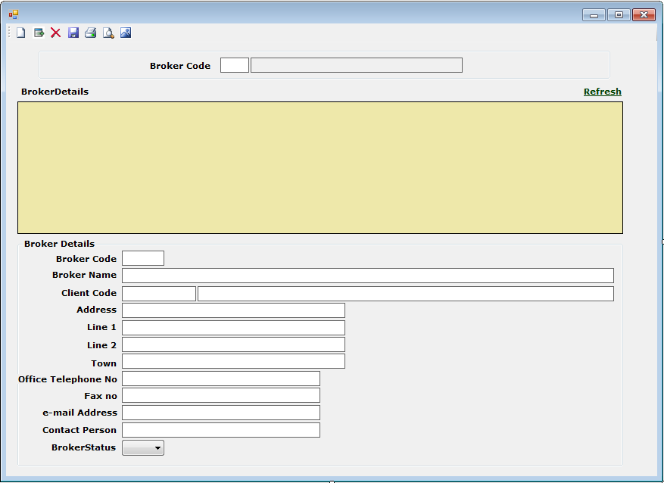

## 3.2 Field validations

Broker_code

This should be a unique code for table MT_Brokerdetails. Characters and numbers allowed. Characters in upper case.

Broker_name

Characters and numbers allowed. Characters in upper case. Cannot be null.

AddressLine1

Characters and numbers allowed. Characters in upper case. Cannot be null.

AddressLine2

Characters and numbers allowed. Characters in upper case.

AddressLine3

Characters and numbers allowed. Characters in upper case.

AddressLine4

Characters and numbers allowed. Characters in upper case. Cannot be null.

Telephone

Telephone Number validation should be there. Only numbers allowed.

FaxNumber

Telephone Number validation should be there. Only numbers allowed.

Emailid

Email ID validation should be there.

Map_client

Should be able to select from the main system client code list or manually enter the client code. Code should validate With the Main system client code. Null value not allowed. Should have authority to change. Cannot be change when margin transaction is available.

Contact_person

All capital. Null value accepted.

Broker_status

Have to select from status list. Null value not allowed. Should have authority to change.